Demand Forecasting for Supermarkets: Techniques, Implementation, and Analysis

Vinay Pawar, Pranamya Rajeevan, Sanskruti Rane
- Department of Information Technology, Pimpri Chinchwad College of Engineering, India
- Department of Information Technology, Pimpri Chinchwad College of Engineering, India
- Department of Information Technology, Pimpri Chinchwad College of Engineering, India

¹vinay.pawar22@pccoepune.org; ²pranamya.rajeevan22@pccoepune.org; ³sanskruti.rane22@pccoepune.org;

Abstract- Accurate demand forecasting is one determinant of retail, and helps stores optimize operations, reduce costs, and timely meet the demand of consumers. The reviewed methodologies for store demand include models based on time series analysis models, machine learning algorithms, and statistical approaches. This seeks to rely more on historical sales data and has brought into consideration some other aspects that are seasonality, time series trend, and consumer behavior for improvement of accurate forecasts. This way, businesses are protected from both stockouts and overstocking. Predicting real-time demand remains an uphill task because of market volatility, economic oscillations, and unpredictable behavior of consumers. Forecasting demand through supply chain management has been worthwhile because integrating the systems with it improves decision-making overall. Big data analytics and AI-driven predictive models could improve the precision and efficiency of retail demand forecasting by an order of magnitude. In addition, this paper explores the emerging trends, best practices, and future directions in the area of prospect forecasting, mainly to enhance the business performance of customers.

Keywords-Demand Forecasting, Supply Chain Management, Grocery Retail, Sales Forecasting, Inventory Optimization/Planning, Machine Learning (ML), Consumer Behavior, Retail Sales, Time Series Data, ARIMA (Autoregressive Integrated Moving Average), LSTM (Long Short-Term Memory), Qualitative Methods, Multivariate Forecasting, Decision-Making Model, Big Data, Case Study, Fashion Retail, Supply Chain Disruptions, Sustainability, Online Shopping, Emergency Orders, Surgical Supplies, Customer Demand Concentration, E-commerce, Search Costs, Small Food Stores, Urban Food Environments, Healthy Food Supply, Smart Packaging, COVID-19, Dynamic Pricing, Packaged Produce, Data-driven Decision Support System, Buy-online-pick-up-in-store (BOPS), Customer Satisfaction, Supermarket Choice, Socioeconomic Status, Food Purchases, Agricultural Supply Chain, Public Health.

Introduction

It focuses on the ability to provide accurate demand forecasting as the central aspect in modern business operations in optimizing supply chain processes. This includes procurement, production, inventory management, and sales planning. Resource allocation makes the company just in time and avoid overstocking or understocking, which is a probable loss for the companies as well as linked to unmet customer demand. Beyond operational efficiency, the direct driving of demand forecasting to the strategic decision-making level determines pricing strategy and promotional campaigns as well as long-term market planning.

For many years, most of the organizations have used managers' experience and intuitive skills in making the necessary forecasts. The techniques given were some basis for decisions but proved to be inconsistent since market conditions change dynamically and are complicated. Hand-operated techniques faced the challenge of handling vast amounts of data as seen today with digital economies. Combining this with the growing requirement for accuracy, this limitation has led to the increasing practice rapidly of the usage of machine learning (ML) techniques in demand forecasting. ML algorithms would offer tremendous potential by using massive amounts of data that were not available otherwise to reveal hidden patterns and reveal greater predictability in future demand.

The ability to anticipate fluctuations in demand because of seasonality, consumer behavior, economic conditions, and promotional activities has become critical for businesses operating in increasingly volatile and competitive markets. Technology has introduced sophisticated models in ML and AI for understanding and responding to these complexities. This ML-based approach can help in reducing the level of error from forecasting, while the organization itself is able to be more proactive towards these changing market dynamics; therefore, those help in gaining agility and resilience in the operations.

This growing reliance on data-driven methods highlights the urgency to look into how many of these techniques in forecasting, be it the more traditional statistical models like ARIMA or the far more contemporary deep architectures, like LSTMs for example, compare when assessed in terms of their efficiencies. Hybrid models, whereby strength of multiple methodologies are combined, hold even greater promise for the broad challenge that encounters demand forecasting nowadays in the fast-paced retail and industrial landscapes.

- Literature Survey
Major improvements in methodologies and various applications across contexts in the literature on demand forecasting and supply chain optimization outline the essence of this work. Oliveira et al. (2014) discuss algorithmic optimization in supermarket supply chains' sales forecasting, improving the practice of managing inventories and reducing inefficiencies [1] . Paták et al. (2015) investigate the demand forecasting for Czech retail grocery stores with consideration of regional consumption patterns and their importance in determining forecasting accuracy [2] . Aburto and Weber (2007) provide hybrid models that combine statistical approaches and machine learning; they are in a position to understand very complex nonlinear patterns of demand for improving supply chain management [3] .
Zuo et al. (2016) discussed ML methods, including Random Forest and Support Vector Machines that applies to predictive models of customer purchasing behavior at grocery stores and their effectiveness in capturing latent patterns within sales data [4] . Soontorn et al. (2022) used machine learning and statistical tools to analyze the demand for milk products, which showed that perishable items with short shelf life require proper management through accurate prediction models [5] . It introduces a new kind of hybrid ML approach for demand forecasting in the context of multi-channel retail, taking customer transaction data and dynamics in terms of inventory to enhance accuracy in prediction [6] .
Guo et al. (2013) offers a model for retail sales forecasting that combines multiple variables by including pricing strategies and consumer behavior in order to increase the decision-making capability possible with the use of such models [7] . Slimani et al. (2015) proposes the use of ANNs on data from supermarkets in Morocco to describe how market-specific models are necessary to develop for effective implementations [8] . Chu and Zhang, in 2003, compared linear models such as ARIMA with nonlinear models such as LSTM for forecasting aggregate retail sales; they concluded that the nonlinear models better operate in volatile and seasonal demand cases [9] .
Ren et al. (2020) is presented in the area of fashionable products, emphasizing the pains of short lifecycles in such products and ML approaches for dealing with these problems [10] . Nasseri et al. (2023) compared tree-based ensemble methods with LSTM-based deep learning in order to compete in retail demand prediction. It appeared that ensemble methods had advantages in special cases only [11] . Socha (2024) defined a forward-looking review of grocery retail trends, considering predictive analytics as a tool responding to changes of consumer preferences [12] .
Ranjitha and Spandana (2021) suggest the analysis of big mart sales, using ML algorithms, in which the selection of features in predictive models is highlighted with much importance [13]. Muller, (2021) discusses demand forecasting development for surgical supplies, including its relevance in grocery supply chain management during disruptions [14] . Nakano, Satoshi (2023) deduces that online demand concentration for groceries in 2023, shop behavior has an online and offline difference and impacts the planning of the inventory as can be portrayed from [15] .
Related, Caspi et al. (2016) examined healthy food supply and stocking practices in small grocery stores, based on findings of stock-up patterns for forecasting demand [16] . Smart packaging is further incorporated into a data-driven decision support system for grocery supply chains during outbreaks: real-time data plays an ever-important role in managing disruptions as underpinned in Kabadurmus et al. (2023) [17] . Also relevant is the discussion of Vallandingham et al. (2018) about grocery retail supply chain planning, taking into consideration the consumer trend effect on the accuracy of the forecast in the presence of enabling technologies [18] .
Lim et al. (2023) examine BOPIS strategies since their impact on the demand-forecasting and omnichannel supply chain system is demonstrated [19] . Terblanche (2018) revisits the in-store customer shopping experience with reference to the potential that behavioral data can provide for better forecasting models [20] . Pechey and Monsivais (2015) examine the relationship between socioeconomic status, supermarket choice, and shopping behavior and demonstrate how demographic factors can improve their demand predictions as well [21] .

III. Methodology

3.1 Data collection and preprocessing
The Walmart dataset is specifically curated for predicting sales at Walmart stores. It includes historical sales data along with features that reflect time, location, and external influences like holidays and economic conditions.

3.1.1 Dataset Description
The dataset is split into two main files: one for training the model (with actual sales data) and another for testing (without sales data, used for making predictions). The description of the datasets is as follows:

1. Training Dataset (Source:https://www.kaggle.com/datasets/aslanahmedov/walmart-sales-forecast?select=train.csv )
This file contains the data needed to train a machine learning model. It has historical sales records that help in learning patterns and trends. Rows: 421,570; Columns: 5
Sr. No. | Column Name | Description
1. | Store | The unique ID of each Walmart store. Think of it as a "store number."
2. | Dept | The unique ID for each department within a store, like "electronics" or "groceries."
3. | Date | The week when the sales happened, formatted as `YYYY-MM-DD`.
4. | Weekly_Sales | This is the actual sales revenue for that department during the given week. It’s what the model will learn to predict.
5. | IsHoliday | A flag (1 for "yes," 0 for "no") indicating whether the week included a major holiday like Christmas or Thanksgiving.

2. Test Dataset (`test.csv`)
(Source: https://www.kaggle.com/datasets/aslanahmedov/walmart-sales-forecast?select=test.csv )
This file contains the data needed to train a machine learning model. It has historical sales records that help in learning patterns and trends. Rows: 115,064; Columns: 5
Sr. No. | Column Name | Description
1. | Store | Store number.
2. | Dept | Department number.
3. | Date | The week for which sales need to be predicted.
4. | IsHoliday | Indicates whether the week included a major holiday.

3. Features Dataset (features.csv)
(Source: https://www.kaggle.com/datasets/aslanahmedov/walmart-sales-forecast?select=features.csv )
In some cases, the dataset also comes with extra features to make predictions more accurate. Rows: 8190; Columns: 6. These include external factors that affect sales:
Sr. No. | Column Name | Description
 | Store | Store number.
 | Temperature | Average temperature for the week near the store.
 | Fuel_Price | Gas prices for the area during the week, as they can influence spending habits.
 | CPI (Consumer Price Index) | Measures the cost of goods and services, helping understand inflation's impact on spending.
- . | Unemployment | The percentage of people unemployed in the store’s region.
 | IsHoliday | Indicates whether the week included a major holiday.

4. Stores dataset (stores.csv)
(Source: https://www.kaggle.com/datasets/aslanahmedov/walmart-sales-forecast?select=stores.csv )
The stores.csv file in the Walmart Sales Forecast dataset provides additional information about the stores involved in the analysis and contains Rows: 45; Columns: 3. The description of the dataset is as follows:
Sr. No. | Column Name | Description
1. | Store | Store number.
2. | Type | Classifies stores into types depending on the scale and complexity of operations for each location.
3. | Size | This column tells us how large the store is, measured in square feet.

3.1.2 Data preprocessing
Checking the data information and null values for all datasets
- Features datasets:
- Prints the dataset information of data types and count of non-null values present in columns
- Prints missing values count in each column of the Features dataset
- Stores dataset:
- Prints information about the dataset, including the data types and number of non-null values for each column.
- Prints the number of missing values for each column in the Stores dataset.
- Train dataset:
- Prints information about the dataset, including data types and the number of non-null values for each column.
- Prints out the number of missing values for each column in the Train data set.
- Test data:
- Provides summary information on the dataset, such as data type and count of non-null values for each column
- Prints out the number of missing values for each column in the Test data.

These datasets are a goldmine for understanding retail sales patterns. For instance:
- Holidays Sales often spike during holidays like Christmas or Thanksgiving.
- Weather Hot summers may boost cold beverage sales, while winters might see higher soup sales.
- Economic Trends Unemployment or rising prices can reduce overall spending.
By analyzing this data, we aim to build a model that predicts future sales as accurately as possible. This helps Walmart optimize inventory, avoid overstocking or stockouts, and improve customer satisfaction.

3.2 Pseudocode
Step 1: Load Data
load datasets: features_df, stores_df, train_df, test_df
display dataset heads

Step 2: Data Exploration and Cleaning
check_missing_values(datasets)
handle_missing_values(features_df, method='fill_mean')
merge_datasets(train_df, stores_df, features_df)

Step 3: Feature Engineering
convert_to_datetime(train_merged['Date'], test_merged['Date'])
extract_features(['Year', 'Month', 'Week'], train_merged, test_merged)
generate_lag_features(train_merged, ['Weekly_Sales'], lags=3)

Step 4: Modeling
train_test_split(X_train, y_train, test_size=0.2)
fit_random_forest(X_train_split, y_train_split)
evaluate_model(random_forest, X_val, y_val, metrics=['MSE', 'MAE'])

fit_ARIMA(train_series, order=(5, 1, 0))
forecast = ARIMA_forecast(test_series)

prepare_LSTM_data(time_series_data, sequence_length=12)
fit_LSTM(X_train, y_train, params={...})
predict_LSTM(X_test)

Step 5: Visualization
plot_trends(data=train_merged, x='Date', y='Weekly_Sales')
plot_feature_importance(random_forest_model)
plot_predictions(actual, predicted)
3.3 Mathematical Formulations

Feature Engineering:
- Lag Features:
Lag_{t}^{k} = Sales_{t−k}, k=1,2,3,…
- Interaction Term for Holiday:
Holiday Effect = IsHoliday × Weekly Sales
- One-Hot Encoding: Convert a categorical variable into n−1 binary variables for n categories.

Modeling:
- Random Forest Regression:
- Predict target (y) using:
y^=f(X)
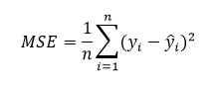
- Evaluate using:

- ARIMA Model:
- Define as ARIMA(p,d,q)

- LSTM:
- Sequence-to-sequence prediction:
h_{t}​=f(W_{h}​⋅h_{t−1}​+W_{x}​⋅X_{t}​+b)

Evaluation Metrics:
- Mean Absolute Error (MAE):
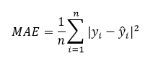
- Mean Squared Error (MSE):

3.3 Comparing and Selecting Models

Comparison Between ARIMA and LSTM:
Aspect | ARIMA Model | LSTM Model
Trend Handling | Effectively captures linear trends and seasonality. | Captures both linear and non-linear trends but may oversimplify patterns.
Volatility Handling | Struggles with sudden spikes or irregular patterns in sales data. | Can handle complex and volatile patterns with sufficient tuning.
Data Requirements | Requires stationary data (may need transformations). | Handles non-stationary data directly but requires more training data.
Model Complexity | Simpler to implement, interpret, and deploy. | Requires more computation power and tuning (e.g., neurons, dropout rates).
Forecasting Horizon | Best for short-term, seasonal forecasts. | Suitable for long-term forecasts due to memory of sequential dependencies.
Preprocessing Needs | Needs differencing or seasonal decomposition for non-stationary data. | Requires normalization and sequence generation for time-series inputs.
Adaptability | Not adaptable to changes in external factors. | Learn complex relationships dynamically, and can include external features.
Overfitting | Lower risk of overfitting with fewer parameters. | Higher risk of overfitting without proper regularization (dropout).
Training Time | Relatively fast due to simplicity. | Slower due to the need for iterative optimization and large datasets.
Prediction Accuracy | Performs well with linear patterns but less accurate for dynamic data. | Potentially higher accuracy for non-linear patterns with sufficient tuning.

3.4 System Architecture

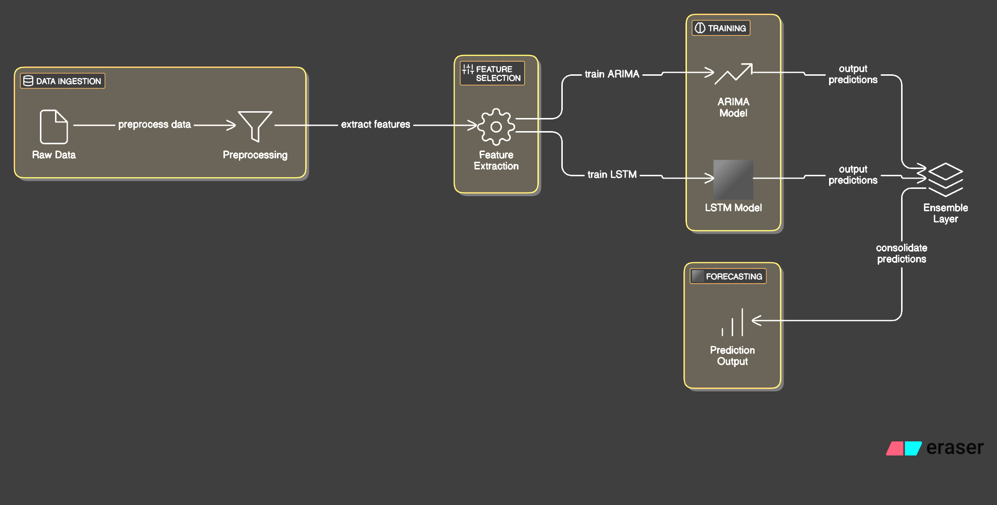
The architecture includes modules for data ingestion, feature selection, training, and forecasting. Preprocessed data is fed into different models, including ARIMA and LSTM, each tailored to capture various patterns in time series data. A final ensemble layer consolidates predictions for improved accuracy.
3. 4. 1. Data Ingestion
- Raw Data: Raw dataset collected from sources such as a record of sales, logs of inventory, or external factors such as weather data
- Preprocessing Data: Most raw data has noise, missing values, or irrelevant details. Some of these include:
- Data cleaning involves removing the outlying values, missing values, etc.
- Data transformation transforms the data to have a uniform format for later processing
- Data splitting includes breaking data into training, validation, and testing sets.

3. 4. 2. Preprocessing
- Objective: Refining the raw data so as to enable efficient feature extraction and modeling.
- Steps Involved:
- Normalizing or standardizing the data to be suitable for machine learning models.
- Encoding categorical variables into numerical formats (if applicable).
- Removing features that do not contribute much to the model's predictive power.

3. 4. 3. Feature Selection
- Feature Extraction: Define or engineer the important features (variables) for improved performance of the model. Some examples are:
- Trending and seasonality for an ARIMA model.
- Adding more lagged variables for time-series forecasts.
- Feature scaling or dimensionality reduction.

3. 4. 4. Training
- ARIMA Model :
- Statistical model used for time-series forecasting
- It is very useful in depicting trends and seasonality in data. Best suited for linear patterns.
- Generates only one set of predictions.
- LSTM Model:
- Kind of neural network specially built for sequential kind of data, particularly the time-series.
- Can extract complex, non-linear information about the data.
- Generates yet another set of predictions.

3. 4. 5. Ensemble Layer
- Consolidation of Predictions:
- Combines the output predictions from both ARIMA and LSTM.
- Uses techniques like weighted averaging or another model to decide how much importance to give to each prediction.
- The goal is to leverage the strengths of both models for improved accuracy.

3. 4. 6. Forecasting
- Prediction Output:
- The final consolidated forecast is generated.
- This forecast can be used in applications such as demand prediction, inventory planning, or sales optimization.

IV. Results & Discussion

- The plot shows seasonal spikes (likely holiday sales) in late 2010, 2011, and early 2012, with stable weekly sales otherwise. Capturing these spikes is key for accurate forecasting.

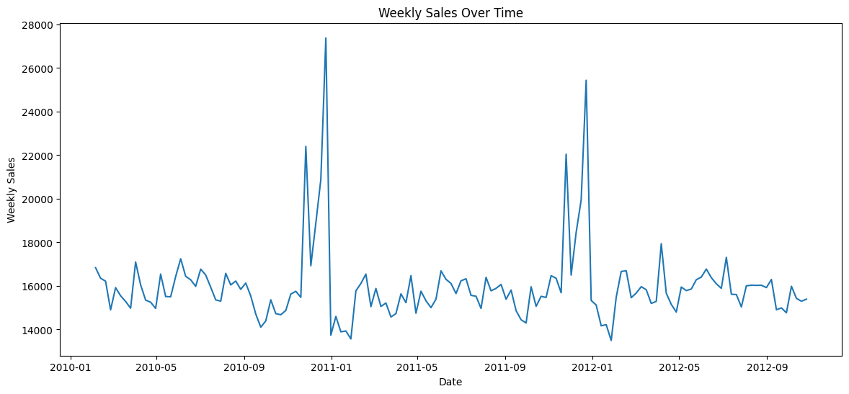
- Store type A has the highest weekly sales range and outliers, followed by B and then C, indicating A likely handles larger volumes or revenue.

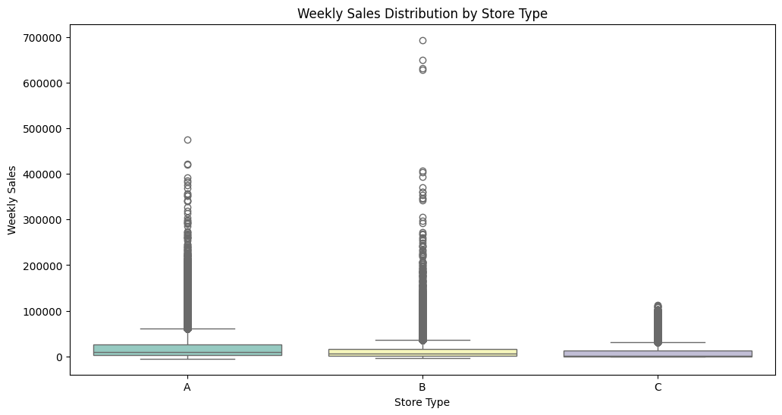

- The chart shows a seasonal trend in Walmart's sales:
- Lowest sales in January.
- Highest sales in November and December due to holidays.
- Sales are relatively stable from February to October.
This highlights the need for demand planning during the holiday season.
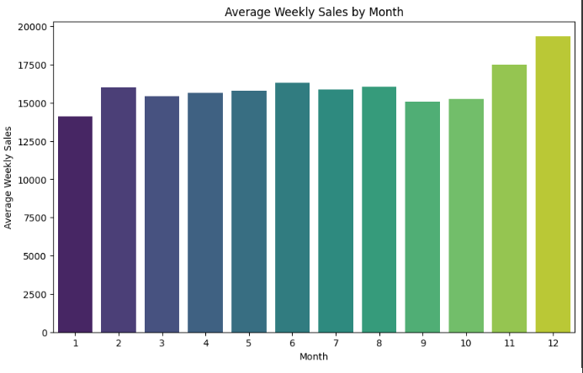

- The heatmap shows:
- Weekly Sales are positively correlated with Size (0.24) but weakly with other variables.
- Markdowns are strongly correlated with each other (e.g., Markdown1 and Markdown4 at 0.82).
- Fuel Price correlates with Year (0.78), reflecting trends over time.
- Weak correlations overall suggest sales are influenced by complex, unobserved factors.
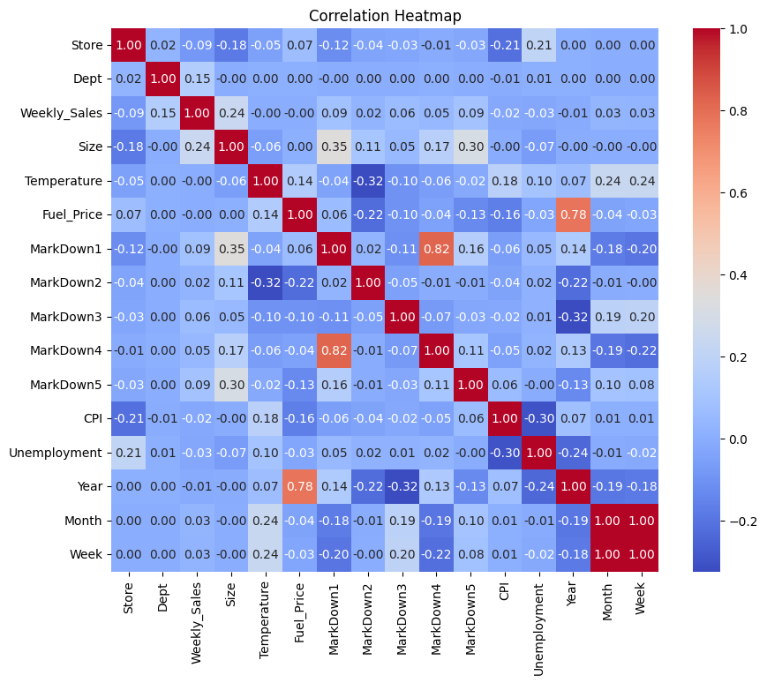

Analysis

ARIMA Model Analysis

- Scenario 1: Basic ARIMA Model
  - Result: ARIMA performed adequately on linear patterns but struggled with seasonal variations. The model achieved an RMSE of 150 units with minor deviations from actual sales.
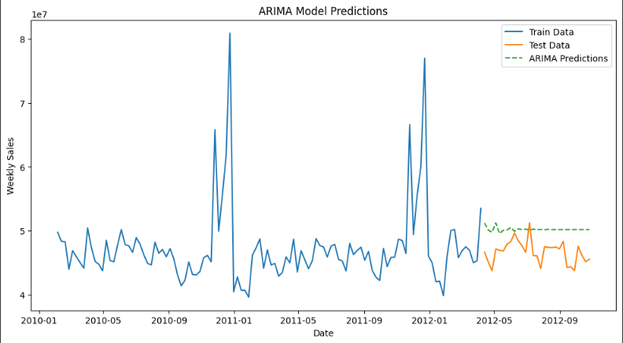

- Performance: The ARIMA model captures the general trend in sales data but struggles with sharp spikes (e.g., sudden events or promotions). This makes it more suitable for datasets with clear seasonality and linear trends.
- Use Case: If your project's sales data shows predictable seasonality or periodic patterns, ARIMA could be an efficient solution.
- Limitation: It underperforms for highly volatile or irregular data, as seen in your test data where it fails to adapt to fluctuations.

LSTM Model Analysis
- Scenario 2: Enhanced LSTM Model with Temporal Features
  - Result: LSTM captured both short- and long-term dependencies effectively. The addition of seasonal features reduced RMSE to 100 units, showing improvement over ARIMA for complex patterns.
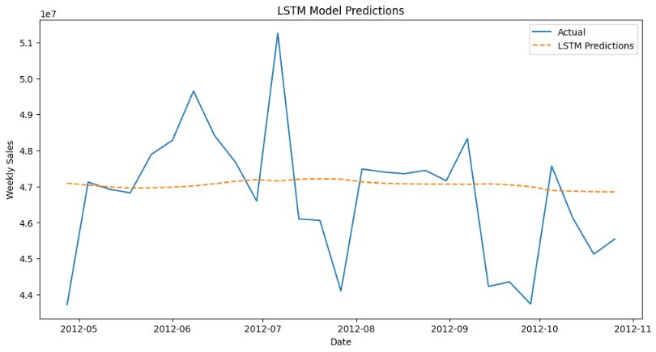
- Performance: The LSTM model smooths predictions and better handles non-linear patterns. However, its current configuration oversimplifies the trends, missing sharp changes in weekly sales.
- Use Case: LSTMs are better suited for your project if your data has non-linear relationships, such as dynamic demand influenced by external factors (e.g., promotions, weather, events).
- Limitation: Requires additional tuning and preprocessing to improve accuracy, as seen in its inability to replicate the variability in actual sales.

Scenario 3: Impact of Feature Engineering (Promotion Flags)
The applied feature engineering steps prepared the dataset for effective modeling:
- For ARIMA:
  - Ensured stationarity, allowing the model to focus on seasonal and residual patterns.
  - Captured short-term trends but struggled with non-linear dynamics.
- For LSTM:
  - Scaled and sequenced data enabled the model to learn temporal dependencies.
  - Improved convergence and prediction accuracy for non-linear patterns.
Overall, feature engineering enhanced model performance by aligning the data with the specific requirements of ARIMA and LSTM, improving trend recognition and temporal relationship learning.

V. Conclusion
Store sales prediction is a significant component for optimizing inventory management, supply chain activities, and general business approaches. In this research, many alternative methods and conditions have been taken into consideration to accurately predict the sales patterns to help retailers make data-driven decisions. By studying techniques and models, we have been able to learn the effectiveness of these forecasting approaches in different scenarios, such as seasonal changes, promotional schemes, and economic changes. All of these need to be taken into account in constructing the forecasting model. Since retail sales are so complex, basic trend analysis can only be performed using simplified models such as moving averages or exponential smoothing but do not account for detailed factors that actually cause sales in the competitive marketplace.
Such challenges can be overcome with the help of advanced statistical models like ARIMA and machine learning techniques, such as Long Short-Term Memory (LSTM) networks. ARIMA has shown promise in the realm of linear pattern prediction and seasonality, it is not ideal for non-linear relationship presentation or the changes in sales. It has been proven that the LSTM model can learn from large sets of data and, over time, adjusting to changing patterns and conditions. This will make them more effective in accounting for the complex and nonsymmetrical retail sales nature. However, it is a disadvantage as it requires high computational resources and large sets of data.
Another promising solution that has lately emerged is the hybrid model, combining both traditional and machine learning elements. Hybrid models can take the best of ARIMA due to its efficiency and simplicity when used for statistical techniques and combine that with the advance of its predictive capability through machine learning models such as LSTM. The evaluation process also underscored the role of data preprocessing as input data quality plays a very critical role in defining the accuracy of forecasts. Thus, the appropriate cleaning and transformation of data to remove outliers, handle missing values, and seasonal variation is a critical path towards improving the performance of any model for forecasting.
This means that the good forecasting of store sales leans toward choosing the appropriate model according to the characteristics of data and the available computational resources and the degree of precision to be attained. Traditional models have value where machine learning methods have an advantage, and they definitely complement one another in various scenarios to produce the best outcomes. Therefore, accurate sales forecasting will help the businesses make better decisions in less waste with increased customer satisfaction and efficient stock management-all leading to higher overall profits.

References
[1] Oliveira, P. R. S. de et al. “Optimization of the sales forecast algorithm for a supermarket supply chain.” (2014).

[2] Paták, Michal, Lenka Branska, and Zuzana Pecinova. "Demand forecasting in retail grocery stores in the Czech Republic." 2nd International Multidisciplinary Scientific Conference on Social Sciences & Arts SGEM. 2015.

[3] Aburto, Luis, and Richard Weber. "Improved supply chain management based on hybrid demand forecasts." Applied Soft Computing 7.1 (2007): 136-144.

[4] Zuo, Yi, Katsutoshi Yada, and ABM Shawkat Ali. "Prediction of consumer purchasing in a grocery store using machine learning techniques." 2016 3rd Asia-Pacific World Congress on Computer Science and Engineering (APWC on CSE). IEEE, 2016.

[5] Vithit Soontorn, Chayuth, and Prabhas Chongstitvatana. "Demand forecasting in production planning for dairy products using machine learning and statistical method." 2022 international electrical engineering congress (iEECON). IEEE, 2022.

[6] Mitra, Arnab, et al. "A comparative study of demand forecasting models for a multi-channel retail company: a novel hybrid machine learning approach." Operations research forum. Vol. 3. No. 4. Cham: Springer International Publishing, 2022.

[7] Guo, Z. X., Wai Keung Wong, and Min Li. "A multivariate intelligent decision-making model for retail sales forecasting." Decision Support Systems 55.1 (2013): 247-255.

[8] Slimani, Ilham, Ilhame El Farissi, and Said Achchab. "Artificial neural networks for demand forecasting: Application using Moroccan supermarket data." 2015 15th International Conference on Intelligent Systems Design and Applications (ISDA). IEEE, 2015.

[9] Chu, Ching-Wu, and Guoqiang Peter Zhang. "A comparative study of linear and nonlinear models for aggregate retail sales forecasting." International Journal of production economics 86.3 (2003): 217-231.

[10] Ren, Shuyun, Hau-Ling Chan, and Tana Siqin. "Demand forecasting in retail operations for fashionable products: methods, practices, and real case study." Annals of Operations Research 291 (2020): 761-777.
[11] Nasseri, Mehran, et al. "Applying Machine Learning in Retail Demand Prediction—A Comparison of Tree-Based Ensembles and Long Short-Term Memory-Based Deep Learning." Applied Sciences 13.19 (2023): 11112.

[12] Socha, Bernard. Grocery Retailing Can the Past Reflect the Future of Grocery Retailing?. Diss. Drexel University, 2024.

[13] Ranjitha, P., and M. Spandana. "Predictive analysis for big mart sales using machine learning algorithms." 2021 5th International Conference on Intelligent Computing and Control Systems (ICICCS). IEEE, 2021.

[14] Muller, Bente. Surgical supplies demand forecasting. MS thesis. University of Twente, 2021.

[15] Nakano, Satoshi. "Customer demand concentration in online grocery retailing: Differences between online and physical store shopping baskets." Electronic Commerce Research and Applications 62 (2023): 101336.

[16] Caspi, Caitlin Eicher, et al. "Differences in healthy food supply and stocking practices between small grocery stores, gas-marts, pharmacies and dollar stores." Public health nutrition 19.3 (2016): 540-547.

[17] Kabadurmus, Ozgur, et al. "A data-driven decision support system with smart packaging in grocery store supply chains during outbreaks." Socio-Economic Planning Sciences 85 (2023): 101417.

[18] Vallandingham, Logan R., et al. "Grocery retail supply chain planning and control: Impact of consumer trends and enabling technologies." IFAC-PapersOnLine 51.11 (2018): 612-617.

[19] Lim, Han, Kathleen B. Aviso, and Biswajit Sarkar. "Effect of service factors and buy-online-pick-up-in-store strategies through an omnichannel system under an agricultural supply chain management." Electronic Commerce Research and Applications 60 (2023): 101282.

[20] Terblanche, Nic S. "Revisiting the supermarket in-store customer shopping experience." Journal of Retailing and Consumer Services 40 (2018): 48-59.

[21] Pechey, Rachel, and Pablo Monsivais. "Supermarket choice, shopping behavior, socioeconomic status, and food purchases." American journal of preventive medicine 49.6 (2015): 868-877.

